**Uncovering the gaming industry’s hidden gems:**

**A comprehensive analysis of video game sales**

**1. INTRODUCTION:**

* 1. **Overview**

Video game sales analysis is the process of collecting and analyzing data about the sales of video games in order to understand market trends and consumer behaviour. This type of analysis can be useful for a variety of purpose, including identifying the most popular game and genres, predicting future sales, and developing market strategies.

**1.2 Purpose**

To create an analytical dashboard and story for providing the insight for making better developing marketing sales.

**2. PROBLEM DEFINITION &DESING THINKING:**

**2.1 Empathy map**

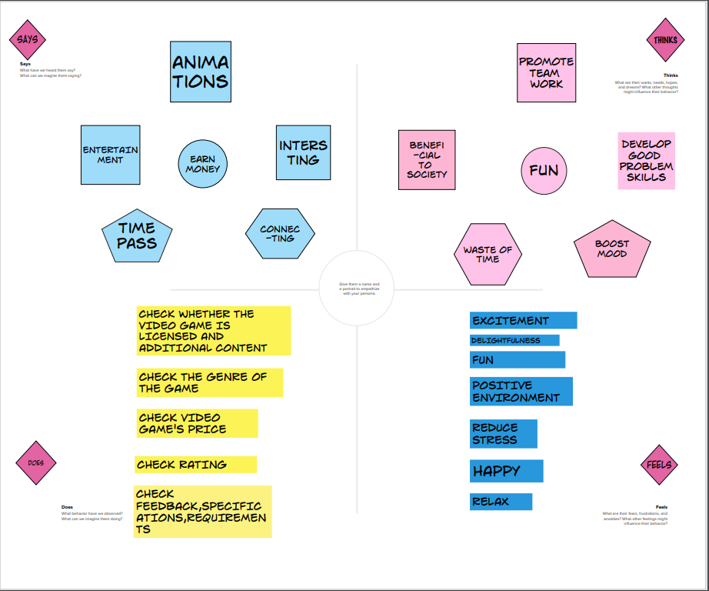

**2.2 Ideation & brainstorming map**

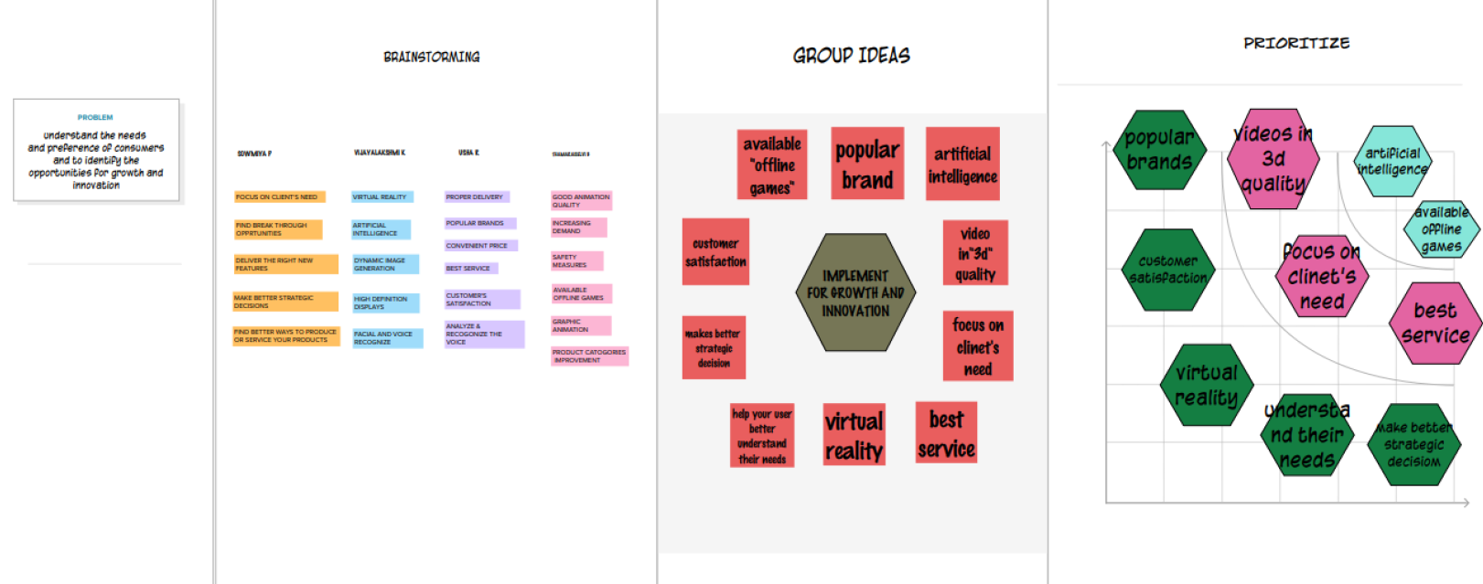**3.** **RESULT:**

**3.1 Story**

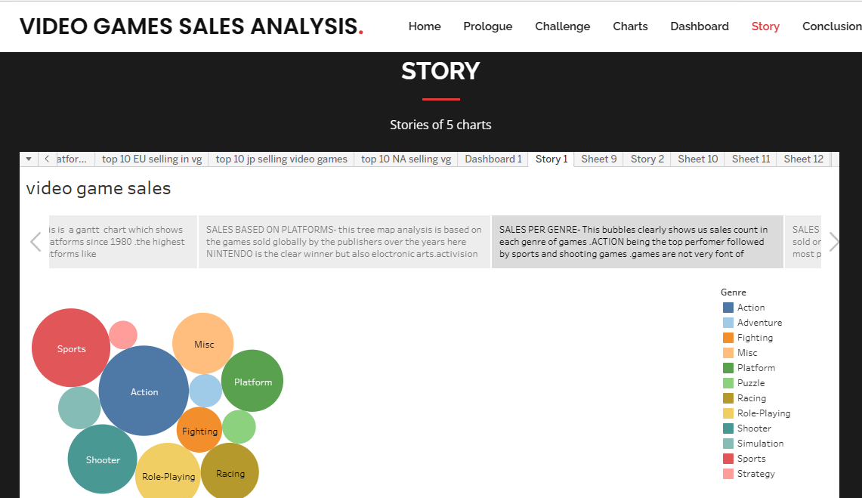

**3.2 Dashboard**

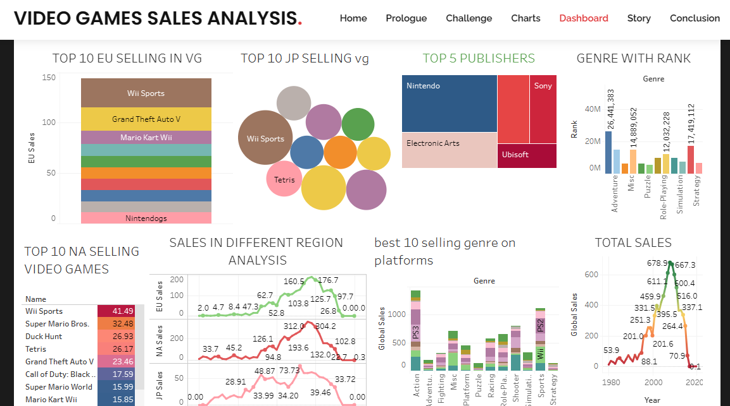

**3.3 web application**



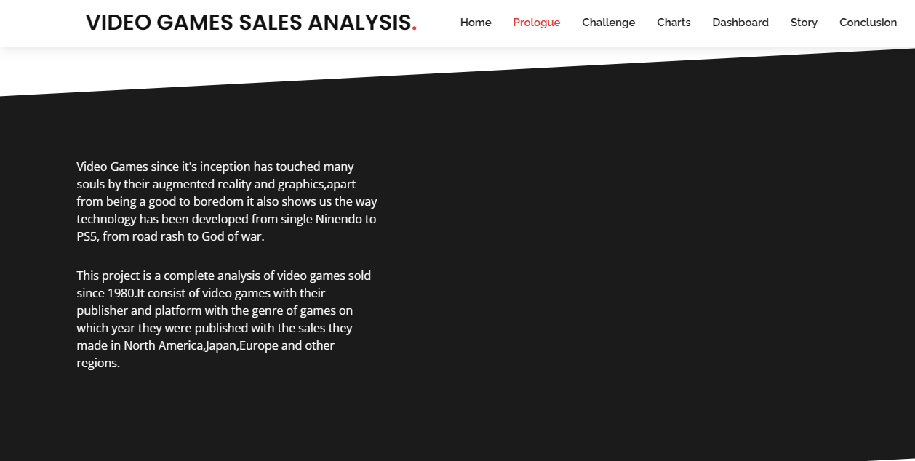

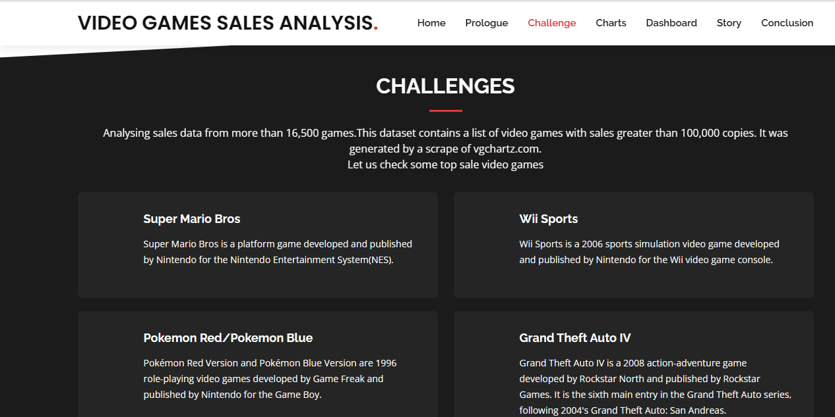

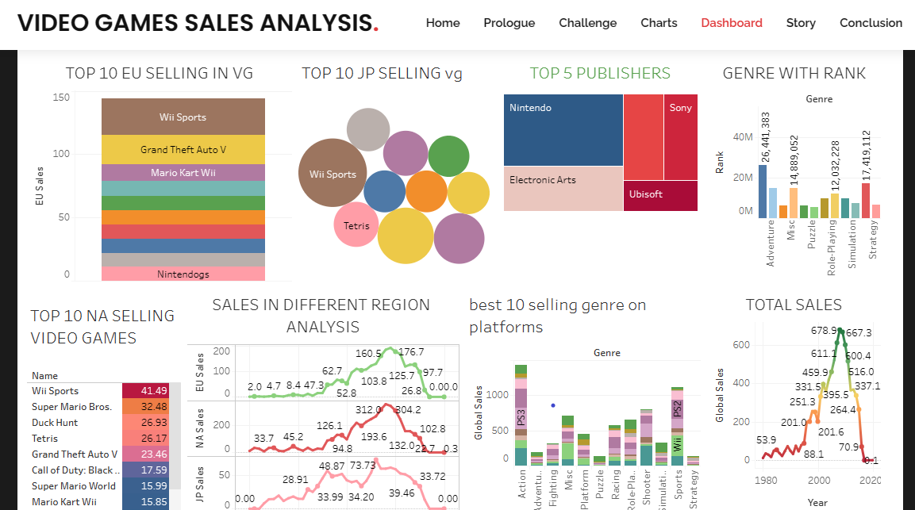



**4. TRAILHEAD PROFILE PUBLIC URL**

**Team lead:** **https://trailblazer.me/id/sparamasivam10**

**6. ADVANTAGES OF THE PROPOSED SOLUTION**

* By the Data Analytics using Tableau we have created many insights like, genre with rank, top 10 selling video game in 3 countries, total sales, best 10 selling genre on platforms.
* Countries in which the video game sales have to be improved were found out.
* We have found out that most popular video game lovers are from NORTH AMERICA.

**7. APPLICATIONS**

* The highest video games are being published on platforms like PS2, PS3, PS4 and PC.
* Game in ACTION genre are the highest sold and most favorite among the games.
* The game sold globally by the publishers over the year NINTENDO is the winner.
* Most popular video game lovers are from NORTH AMERICA.
* The year 2008 seems to be the peak year .where, the sales was highest.

**8. CONCLUSIon**

* It is best option for the games releasing in pc and also if you are looking for “action” games for the publishers “NINTENDO” as they have sold the highest no of games.
* The love for the video game was increasing till 2008. But it is gradually decreasing since then, this is due to the lack of creativity, awareness or interest.
* This is reason why most of the games are sold in NORTH AMERICA as compared to the other part of the world.
* Well, there are lots of other efforts going into creating a single game and due to modern era mobile games other platform are getting deprived of the other attention which had created a lot of awesome experience for games from 1980-2010.

**8. FUTURE SCOPE**

* The future of the video game industry looks dazzling consumer demand is growing, technology is advancing quickly and new monetization model is taking off brain’s analysis forecasts that global revenue for games could grow by more than 50% over the next five years.
* Gaming will take consumer’s time from other forms of media and be the foundational platform for both other media and non media experience, becoming an ever part of our daily lives.

**9. APPENDIX**

1. **Source Code**

[**vgsales.html**](vgsales.html)

